Table of Contents

1. Introduction 2

1.1 Justification for the project 2

1.1.1 Background of the project 2

1.1.2 Problem statement 2

1.2 Description of the project 2

1.2.1 Features 2

1.2.2 Overview of the project 2

2. Scope of the project 2

2.1 Scope 2

2.2 Limitation 2

2.3 Aims 2

2.4 Objectives 2

2.5 Overview of the scope 2

3. Development Methodology 2

3.1 Waterfall Model 2

3.2 Design pattern 2

3.2.1 Model view controller pattern 2

3.3 System Architecture 2

4. Project plan 2

4.1 Work breakdown structure 2

4.2 Milestones 2

4.3 Scheduling: GANTT CHART 2

4.3.1 Time Estimation table 2

4.3.2 GANTT CHART 2

5. Risk Management 2

6. Configuration Management 2

7. Conclusion 2

8. References 3

# Introduction

Nowadays, most people from child-ageing are suffering from teeth issues. By recognizing this issues, I have thought to make my project about dental clinic management system. Here, all dental services treatment will be provided to patients for their betterment. First of all, patients details will be recorded, details of treatment and which doctor has been treated to patients will be also be recorded .DCMS records all the details of the clinic and helps to solve the problems of patients. To make this project success, I have used **PHP** for programming and my **SQL** for database.

# Justification for the project

The following are the reasons for accessing dental clinic management system.

* In past, recording system is on the based upon paper so, time consuming is too high. DMS avoid time consuming and deliver high efficiency.
* Here, only authorized people can manipulate data which delivers integrity and confidentiality.
* Better security is also provided.

## Background of the project

In today’s world, many organizations uses old recording system. They did work manually. Patients have to wait a long time for appointment and also consult with doctor.

## Problem statement

The following problems will be exists in paper based recording system:

* There will be lack of security.
* Data duplication will be increases.
* Too much time consuming system
* Data will be lose and not long lasting.
* Appointment will be delay.

## Description of the project

## 

## Features

The features of my project are is there are two type of login system. **User** and **Admin.**

CRUD functions is carried by users. Here, is also online process where patients can login for an appointment. After login the following are the features that patients can see:

* **Previous treatment history can see by patients.**
* **There will be price list of treatment and different types of treatment that has been treated on clinic can also see by patients.**
* **Admin can connect videos about treatment methods.**
* **Admin can generate bills.**
* **Patients can see all the detailed information about clinic.**

## Overview of the project

This project has been created to give better treatment to patients and improve their oral health by consults with experience dental doctors. This project will not consume too much time of patients and through online they can see all the features and treatment process. There will be more security.

# Scope of the project

## 2.1 Scope

This project is introduced to store the data and information of dental clinic management system. Can upgrade and update viewing process of patients. Through this project can improve information system.

## 2.2 Limitation

* Educated people only required and use to see this system.
* Billing payment system is not provided through online.
* For treatment appointment, patients need to register all their details.

## 2.3 Aims

The main aims of this project are:

* Reducing human efforts.
* To provide better functionality.
* Avoiding Data redundancy of the patients.

## 2.4 Objectives

* To retrieve patients history.
* Promoting Business services for upcoming days.
* Update and upgrade existing system.
* To reduce manual work.

## 

## 2.5 Overview of the scope

Many organizations and services of dental has been stored a data on a manual paper based. So, by using this functionality they can provide better data security. Time and cost can be also saved and is very profitable for a business.

# 3. Development Methodology

Development Methodology is a framework that is used to provide the structure, plan and control the process of developing the information system.

## 

## 3.1 Waterfall Model

For the project, I have use waterfall model which is simple to use and easy to understand. We used waterfall model for small project. Here, dental clinic management project is used for small organization so, waterfall model is suitable. It is a project manageable tools that emphasis all the way from analysis all the way to design. The following are the steps of waterfall model:

1. Requirement design
2. System analysis
3. Implementation
4. Testing
5. Deployment
6. Maintenance

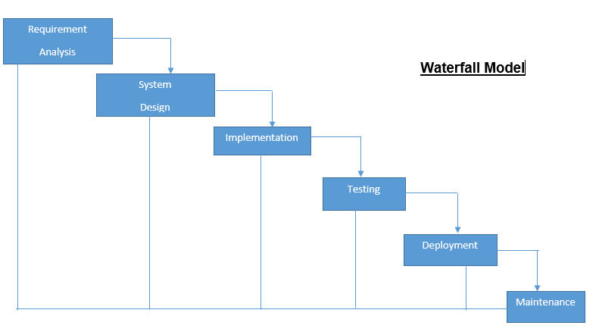

Figure 1: Waterfall Model

**Advantages:**

* It is very useful for small project.
* It is easy to manage.
* Phases are completed at one time.

**Disadvantages:**

* High amount of risk.
* It is not good model for complex project.

## Design pattern

Design patterns are like algorithm for object design which is allow for certain kinds of object interaction to be codified into an implementation independent relationship.

## 3.2.1 Model view controller pattern

For the development of the project, I have chosen MVC Design pattern. MVC is used to distribute the logic of different layers in a program in independent units and faster development process. Following are the components on which design are depends. [(Journal Dev, 2016)](CP%20proposal.docx)

1. Model: It manages the persistence’s of spreadsheet state.
2. Controller: It handles user input and also responsible for modify a model.
3. View: It shows how the data is present in the application.

## C:\Users\Shilu(Luri)\AppData\Local\Microsoft\Windows\INetCache\Content.MSO\C501824F.tmp

Figure 2: MVC design

## 

## System Architecture

System architecture is a conceptual model which clarify the structure, behavior and more view of a system. It contains component of system and developed sub-system.

System architecture consists 3 tier i.e. application tier on the top-most level, business logic tier on the middle and data management tier on the bottom.

1. **Presentation tier:** It main function is to translate a task to something that user can understand.
2. **Business Logic tier:** It makes logical decision and performs calculation.
3. **Data management tier:** Information is stored in this tier from file system. Then, information is passed back to logics tier for processing and again pass to users.

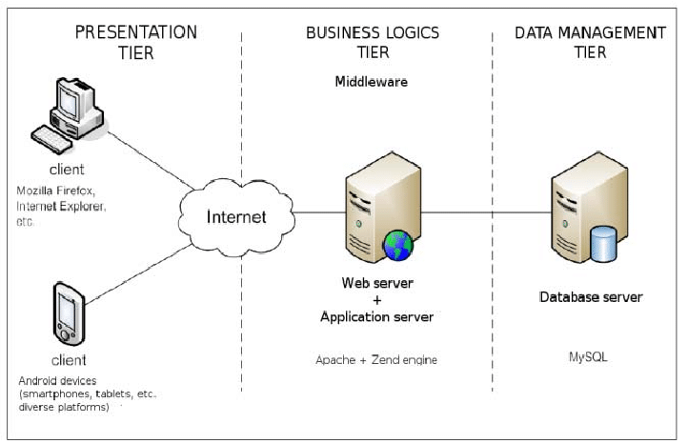

Figure 3: Architecture of 3 tiers

# 4. Project plan

## 4.1 Work breakdown structure

WBS is a method used for dividing complex project into smaller one which can be more manageable. This process makes work to get easier and done faster, effectively.

WBS is also called hierarchical tree structures that breaks down the tasks, one can break them down into different levels of detail. For a project execution, project manager use WBS.

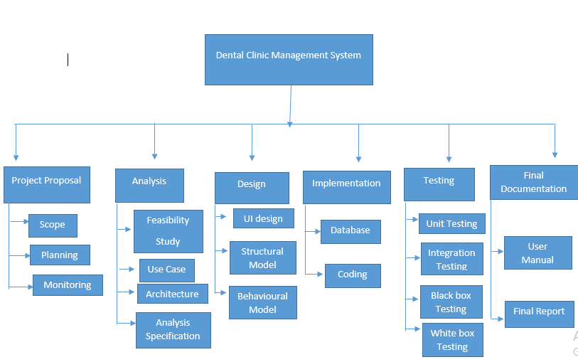

Figure 4: Work Breakdown structure

## 

|  |  |  |
| --- | --- | --- |
| **WBS** | **TASK NAME** | **NUM OF DAYS** |
| 0 | **Dental CLINIC MANAGEMENT SYSTEM** | 108 |
| 1  1.1  1.2  1.3 | **PROJECT PROPOSAL**  SCOPE  PLANNING  MONITORING | 16  5  8  3 |
| 2  2.1  2.2  2.3  2.4 | **ANALYSIS**  FEASIBLITY STUDY  USE CASE  ARCHITECTURE(initial class diagram)  ANALYSIS SPECIFICATION | 28  10  5  7  6 |
| 3  3.1  3.2  3.3 | **DESIGN**  UI DESIGN  STRUCTURAL MODEL  BEHAVIOURAL MODEL | 25  13  6  6 |
| 4  4.1  4.2 | **IMPLEMENTATION**  DATABASE  CODING | 20  10  10 |
| 5  5.1  5.2  5.3  5.4 | **TESTING**  UNIT TESTING  INTEGRATION TESTING  BLACK BOX TESTING  WHITEBOX TESTING | 7  2  2  2  1 |
| 6  6.1  6.2 | **FINAL DOCUMENTATION**  USER MANUAL  FINAL REPORT | 11  6  5 |

## 

## 4.2 Milestones

My project is about Dental Clinic Management System. This project allocated total time 108 days. The following are the process that are undertaken for the successful project.

1. **Project Proposal:** Total time consuming for project proposal is 16 days. i.e. 5 days for scope because I have to research this, 8 days for planning because I have to plan all and 3 days for monitoring.
2. **Analysis:** It takes 28 days for analysis. i.e. 10 days for feasibility study, 5 days for Use Case because I take this time for thinking, 7 days for architecture and 6 days for analysis specification.
3. **Design:** Total time consuming for design phase is 25 days. i.e. 13 days for UI design because I feel difficult to design, 6 days for structural model and 6 days for behavioral model.
4. **Implementation:** Total time consuming for implementation is 20 days. i.e. 10 days for database and 10 days for coding.
5. **Testing**: It takes 7 days for the completion of testing. i.e. 2 days for unit testing, 2 days for integration testing, 2 days for Black Box testing and 1 days for white Box testing.
6. **Final Documentation:** Total time taken for completion of final documentation is 11 days. i.e. 6 days for usual manual and 5 days for presentation.

|  |  |  |  |  |
| --- | --- | --- | --- | --- |
| **WBS** | **TASK NAME** | **Start Days** | **End days** | **NUM OF DAYS** |
| 1  1.1  1.2  1.3 | **PROJECT PROPOSAL**  SCOPE  PLANNING  MONITORING | 25th March  30th March  7th April | 29th March  6th April  9th April | 16  5  8  3 |
| 2  2.1  2.2  2.3  2.4 | **ANALYSIS**  FEASIBLITY STUDY  USE CASE  ARCHITECTURE(initial class diagram)  ANALYSIS SPECIFICATION | 10th April  20th April  25th April  2th May | 19th April  24th April  1 May  7th May | 28  10  5  7  6 |
| 3  3.1  3.2  3.3 | **DESIGN**  UI DESIGN  STRUCTURAL MODEL  BEHAVIOURAL MODEL | 8th May  21 May  27th May | 20th May  26th May  1 June | 25  13  6  6 |
| 4  4.1  4.2 | **IMPLEMENTATION**  DATABASE  CODING | 2 June  12th June | 11th June  21 June | 20  10  10 |
| 5  5.1  5.2  5.3  5.4 | **TESTING**  UNIT TESTING  INTEGRATION TESTING  BLACK BOX TESTING  WHITEBOX TESTING | 22 June  24th June  26th June  28th June | 23 June  25th June  27th June  28th June | 7  2  2  2  1 |
| 6  6.1  6.2 | **FINAL DOCUMENTATION**  USER MANUAL  FINAL REPORT | 29th June  5th July | 4th July  9th July | 11  6  5 |

## 

## 4.3 Scheduling: GANTT CHART

## 4.3.1 Time Estimation table

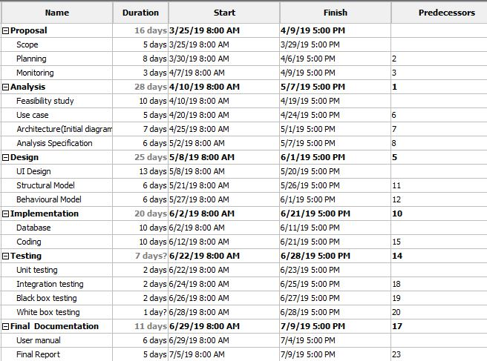

Figure 5: Task division on basis of time

## 

## 4.3.2 GANTT CHART

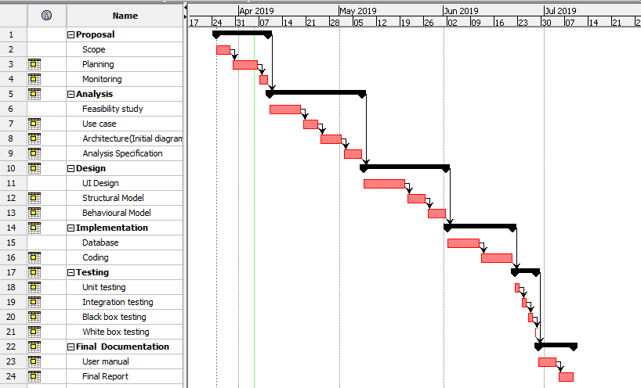

Figure 6: Gantt chart

## 

## 5. Risk Management

Risk management is the process of identifying potential risk, controlling threats and analyze risk of a project. It is a system used for preventing or reducing likelihood.

The possible risk are:

1. Natural disaster
2. Bad design
3. Wrong time estimation
4. Requirement does not meet
5. Insufficient resources

.

Following are the values of Likelihood**.**

|  |  |
| --- | --- |
| Likelihood | Values |
| Low | 1 |
| Medium | 2 |
| High | 3 |

Fig: risk likelihood

Following are the values of consequence.

|  |  |
| --- | --- |
| Consequence | Values |
| Very low | 1 |
| Low | 2 |
| Medium | 3 |
| High | 4 |
| Very high | 5 |

Fig: risk consequence

**Impact = Likelihood * consequences**

|  |  |  |  |  |  |
| --- | --- | --- | --- | --- | --- |
| SN | Risks | Likelihood | Consequence | Impact | Actions |
| 1 | Natural disaster | 1 | 5 | 5 | Backup plan |
| 2 | Bad Design | 1 | 4 | 4 | Training should be provided. |
| 3 | Wrong  time estimation | 3 | 2 | 6 | Tasks should be divided on bases of timing |
| 4 | Requirement does not meet | 1 | 3 | 3 | Planning should be done properly. |
| 5 | Insufficient resources | 2 | 3 | 6 | Needed resources should be collected. |

# 6. Configuration Management

It is the discipline of ensuring that all the software and hardware assets which they known and can used to track at all times. It is an integral part of quality management at which delivered meets the specific criteria.

The importance of CM is to provide for the evaluation of changes including effects on technical and operational performance. CM should be fulfilled with detailed policies, procedures to maintain a version. [(Townsend, 2019)](CP%20proposal.docx#aa)

**Steps of configuration Management:**

* Plan and manage CM
* Identification of Arrangement
* Control of configuration
* Accounting status of configuration
* Configuration verification and Audit

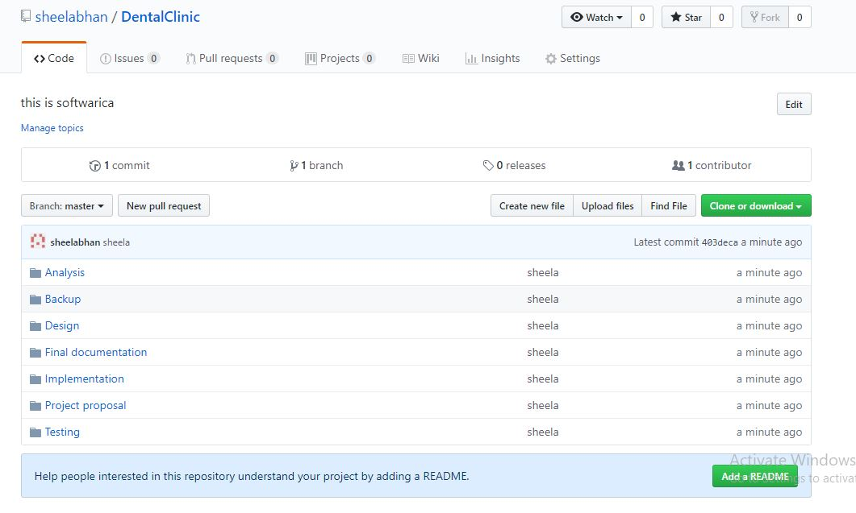

Figure 7: GitHub

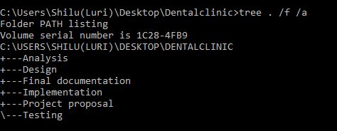

Figure 8: Tree structure

# 

**Git Id**: <https://github.com/sheelabhan/DentalClinic>

# 7. Conclusion

Finally, my project about ‘Dental Clinic Management system’ has been completed. I have described all the aims, objectives and scope related to project. I have mention water fall model because my project is small and is very suitable for this project. I have used MVC design pattern and 3-tier in system architecture. After that, WBS has been introduced which break large project into smaller one and make easier project. Then, breaks down projects according to timing. The main objective of the project to developed web based management system.

# 8. References

# Available at: https://www.journaldev.com/16974/mvc-design-pattern [Accessed 5 Apr. 2019].

# .Available at: https://www.techwell.com/techwell-insights/2013/09/why-configuration-management-important [Accessed 5 Apr. 2019].